**Proposal:**  
To determine the optimal concentration of auxin and cytokinin for robust tissue culture in *Petunia x hybrida* var “Supertuina White” via distributed inter-lab effort.

**Intro:**

The particular cultivars of Petunia x hybrida known as “Supertunia White” and “Supertunia Royal Velvet” are known to be sterile (cannot self-pollinate nor receive pollen from elsewhere), are resistant to a plethora of diseases, flower abundantly, and are hardy across many temperate zones. These lines of petunia are available commercially and are a garden favorite among many flower enthusiasts. Preliminary work by Binomica Labs, in conjunction with Weill Cornell Medical College, has produced a 300x complete genome sequence (unassembled raw data) for both cultivars and genetic engineering has been attempted via Agrobacterium-mediated gene transfer. Current published methods for working with petunia focus on the standard laboratory petunia variety known as the “Mitchell Diploid” and does not translate well to other more inbred hybrids of this flowering plant.

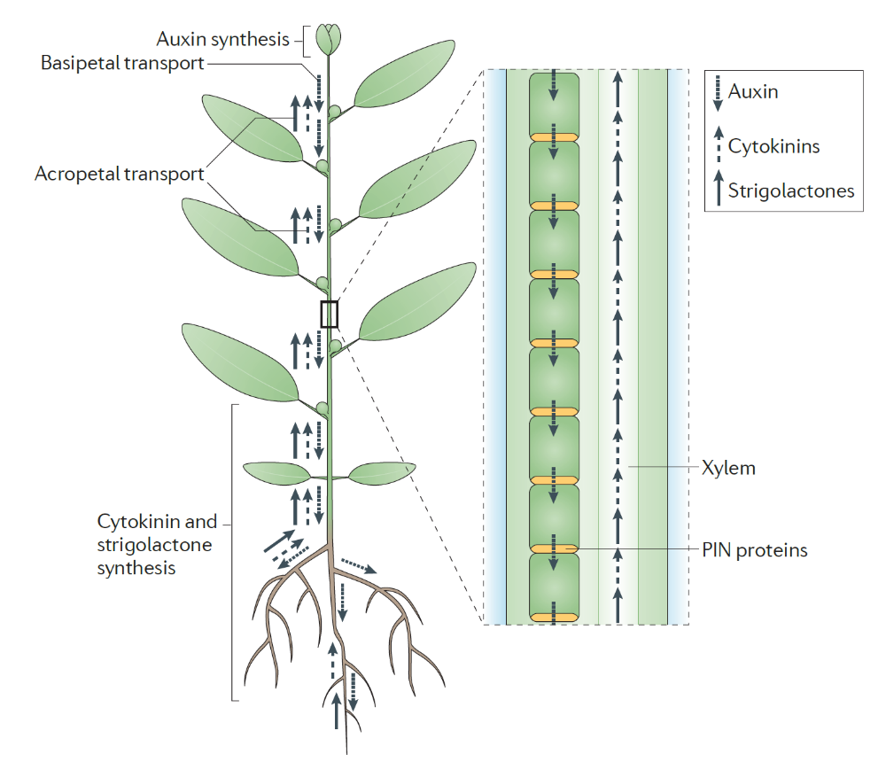All plants regulate the growth and development of their physiology by means of signaling molecules. The natural (hormones) and synthetic plant growth regulators are found in all terrestrial plants and are often kept in a particular ratio in different tissues across the same plant. The two main chemical families that represent these growth regulators are auxins and cytokinins. There are other classes of plant growth regulators but for this experiment, we want to focus on the cheapest and most readily available chemicals that also have the advantage of being very thermostable – benzylaminopurine and napthaleneacetic acid.

During a plant tissue culture experiment, we exploit these hormone ratios in order to reprogram (dedifferentiate) leaf cells to become individual plants via a process known as somatic embryogenesis which roughly translates to “babies from the body”. All plant cells, unlike mammalian cells, are a kind of “stem cells” such that a whole plant may be regenerated from a single cell from any tissue type. There are caveats to this if the proper genetic machinery is missing which is the case for some plants especially monocots like corn, but for the vast majority of plants this trait holds true. By exposing leaf tissue to a particular ratio of the two hormone families, a dedifferentiation event may occur where the leaf cells begin to form a kind of “Platonic form”, a mass of cells (callus) that look nothing like the plant it came from but has all the necessary genetic and cellular elements needed to be a plant in theory. From this amorphous callus state, a cascade of genetic switches begin to flip resulting in cellular re-differentiation. The cells are now reprogrammed to run the code of an embryo of said plant and begin to show the tell tale signs of embryogenesis.

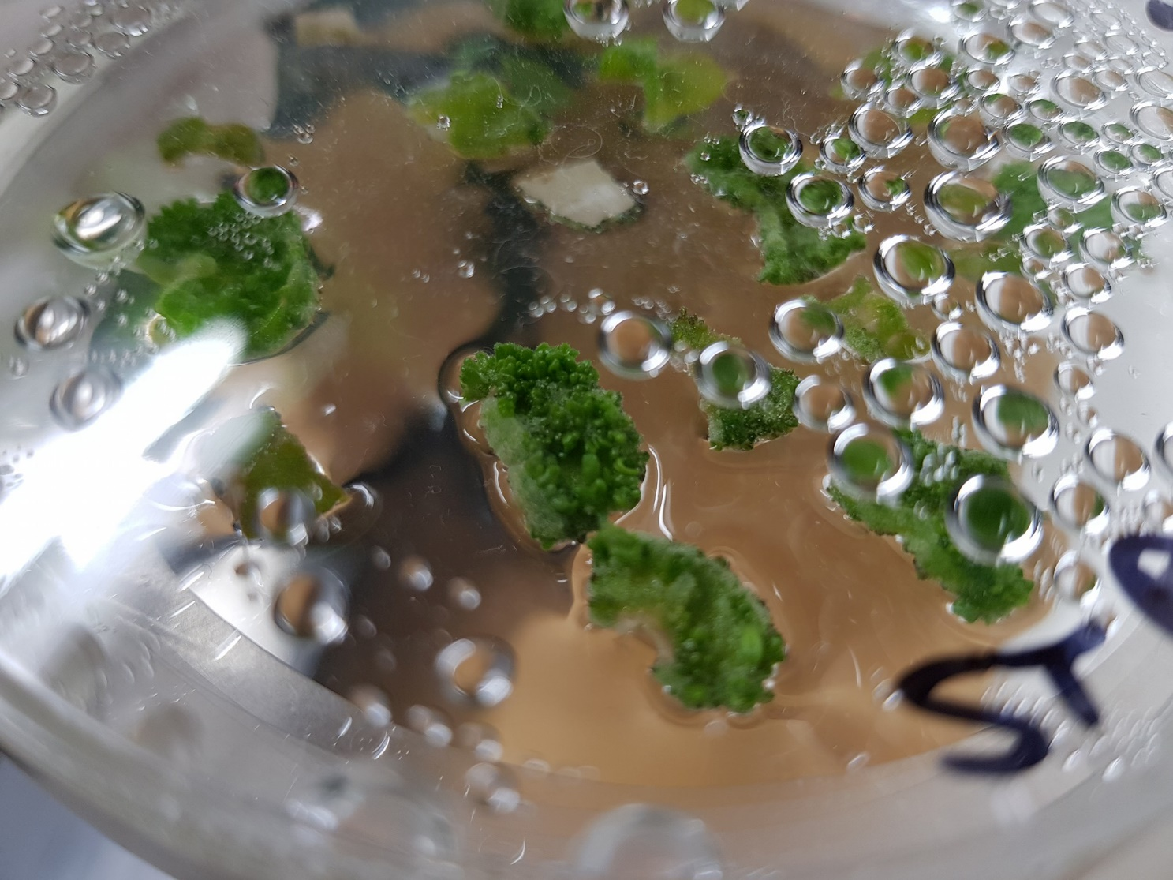

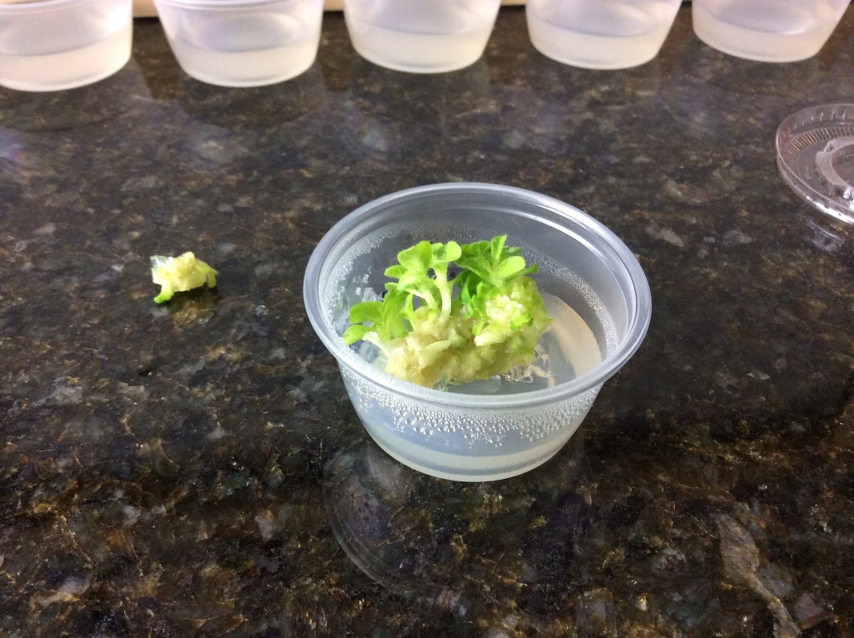After a series of replates (2 week intervals) which vary from species to species, and in our case cultivar to cultivar, small baby plantlets begin to form and will require transplantation into new vessels. At this point the process is similar to that of inducing rooting in traditional horticulture. A plant cutting (stem and few leaves) are dipped into a solution of rooting hormone and allowed to incubate in high humidity until roots begin to form. Once rooted, the plants may then be transferred to soil and grown as regular plants in greenhouse conditions.

During our preliminary experiments, published methodologies on the tissue culture and regeneration of petunia from leaf disks have shown to be sub-par for our particular cultivar thus we wish to open up this experiment to any and all interested in participating. The entire plant is open source (will host a torrent of our genomes on The Pirate Bay). All work done by any participants will be properly cited and the rubric for this experiment can be applied to any/all plants such that individuals can develop their own methodologies and contribute meaningfully to the scientific conversation at large. This experiment will enable the participant to familiarize themselves with plant tissue culture, aseptic technique, general laboratory practices (making media, adjusting pH, etc) and enable further experimentation along the lines of the researcher’s interest with minimal investment beyond the initial purchases. Once a tissue culture process is established, the generation of plants and the experiments therein would cost pennies per plate of culture. The practice, craft, and art of plant tissue culture can be an enjoyable as well as educational endeavor with many years of rewarding work to those willing to hone their skills. As a means of practicing how to manage a distributed experimental pipeline, we invite and encourage anyone and everyone to participate in whatever capacity they can. The information below will outline the procedures and data recording formats required for this experiment as well as the material, consumable, and infrastructure costs associated with this experiment in dollar amounts at the time of writing. A more detailed procurement guide will follow this document at a later time which is also open to public edit and commentary.

**Materials:**  
A brief summary of the needed laboratory equipment, chemicals, consumables, and live material to proceed with this experiment is as follows:  
  
*Equipment*

-Autoclave or Pressure cooker (able to blacken an autoclave tape strip)

-Scale or analytical balance capable of resolving to 1mg or less (100g minimum capacity)

-pH meter with automatic temperature compensation (resolution to 0.01 pH units)

-Magnetic stirrer

-Grow light setup (3000 lux at 18” height ideally, cool white fluorescent lights)

-Laminar flow hood (or dead air box verified with open media dish test)

*Tools*

-Pipettes (10uL, 20uL, 200uL, 1000uL)

-fine point metal tweezers (6” or longer, as many as you can afford, minimum 10)

-6mm biopsy punch (these can be reused and alternative metal punches are available)

-metal spoon or spatulas for reagent weighing

*Glassware/Plasticware*

-40x 100mm polypropylene petri dishes (glass can work but avoid one time use polystyrene)

-2x 1L beakers for making media (autoclavable plastic or glass)

-1L volumetric flask (Class A, plastic or glass)

-glass jars with autoclavable lid for sterilizing leaf tissue (4 medium size holding at least 500mL)

-20x sterile graduated 50mL centrifuge tubes (polypropylene body, can be washed and re-autoclaved)

-50mL tube stand (3D printed, cardboard, carved from wood, as long as it holds a 50mL tube upright)

- 2oz polypropylene condiment cups (for transferring petunia if you wish to complete the regeneration)

-plant starter trays (small 6 cell per tray variant, for establishing petunia in soil if desired)

-weigh boats for measuring powdered reagents

-sterile pipette tips for 10, 20, 200, and 1000uL pipettes

*Reagents*

6-Benzylaminopurine 1mg/mL Stock Solution (buy it ready made since the concentration is critical)

Napthaleneacetic acid 1mg/mL Stock Solution (see above comment)

MS Basal Medium w/ Gamborg B5 Vitamins (10L’s worth of powder will suffice, we only need 4.44g)

MES Monohydrate Buffer

Sucrose (table sugar works but lab grade is ideal)

Gelrite/Gelzan (agar if absolutely necessary but ideally Gelrite or Gelzan)

Distilled Water (must be distilled, not just RO or DI)

Potassium Hydroxide 1M Solution (for adjusting pH)

pH Calibration Buffers (set of three either NIST or USA values)

ef-Chlor NaDCC Water Purification Tablets (167mg version, for plant sterilization)

Triton X-100, Tween20, or non-fragranced non-dyed dish soap (plant sterilization)

Isopropyl 70% for surface cleaning of aseptic areas

Household Bleach (freshly prepared by adjusting to 10% with water)

*Miscellaneous Items*

Autoclave tape

Aluminum foil

Self-healing cutting mat (the green one with the yellow lines used for arts and crafts)

Magnetic Stir Bar capable of moving 500mL of liquid

Magnetic stir bar capable of moving 1000mL of liquid

Parafilm Tape (important for petri dish sealing)

Perlite (optional)

Vermiculite (optional)

Jack’s Classic 20-20-20 Fertilizer (optional)

Time

Interest in plants

Patience

**Methods:**

1. Obtain a Supertunia White plant from a local grower or Amazon. Proven Winners’s Brand is the rightful patent holder for the variety and will ensure cultivar is correct. Patent# PP25485.
2. Grow petunia until at least 20 healthy leaves of 2cm length or more are present.
3. Prepare 400mL of 250ppm NaDCC by dissolving 1 ef-chlor 167mg tablet in 50mL of distilled water then, dilute to 400mL with distilled water.
4. Add 100uL of 10% Triton X-100 or 10uL of dish soap to the ef-chlor sterilant
5. Cut off the petunia leaves aseptically from the plant using a scissor wiped down with 70% isopropyl alcohol.
6. Place the petunia leaves in the sterilant solution, toss in a 500mL magnetic stir bar, and cap the jar tightly.
7. Place the sterilizing leaves on a magnetic stirrer on very low speed, enough to gently spin the leaves floating above but not fast enough to damage the tissue by impact. Allow this mixture to stir overnight.
8. Before you leave for the day, place at least 700mL worth of distilled water into an autoclavable container and run the autoclave along with a piece of self-healing cutting mat wrapped in aluminum foil, three empty jars of 250mL or more with lids, and at least 10 tweezers in an autoclavable cup (tips point down onto a bit of paper towel) also wrapped in aluminum foil. Don’t forget a strip of autoclave tape. You can let the water cool in the autoclave overnight if need be.
9. The following day (at least 8 hours later), surface sterilize your laminar flow workspace with 70% isopropanol. Spray generously and allow to dry in the breeze, twice. If using a dead air box, first prepare a 10% bleach solution and then with gloves on, wipe down every surface (including roof and walls). Allow this to dry for at least 20 minutes and then spray down the work surface with 70% isopropanol. Your dead air box is now as sterile as one could hope.
10. Bring the three sterile jars autoclaved the night before and the 700mL of distilled water and distribute the water evenly across the 3 jars. If any water is leftover, add more to the third jar as this will be our holding tank for the sterile petunia.
11. Place the cup of sterile tweezers onto your sterile work surface, being sure to spray down with 70% isopropanol before entering. Do not take off the aluminum foil cover before entering the sterile area.
12. Remove the sterilization jar full of NaDCC solution and petunia leaves from the stirrer and spray down with 70% isopropanol before entering the laminar flow/dead air box.
13. Under sterile conditions, carefully remove the lid of the sterilization jar and using a sterile tweezer, dip each leaf one by one into the three jars of sterile water in series leaving the leaf to float in the third jar.
14. Repeat step 12 for all of the leaves until they are washed and floating on standby in sterile water.
15. Autoclave a 1L beaker with lid covered in aluminum foil and a strip of autoclave tape
16. Prepare 1L of MS media using the following recipe added to 800mL of distilled water:
    1. MS Basal Media w/ Gamborg B5 Vitamins 4.44 grams
    2. Sucrose 30 grams
    3. MES Monohydrate Buffer 0.5 grams
    4. Allow solution to stir with a 1000mL stir bar in a 1L beaker until dissolved
    5. Top off solution to a little under 1000mL with distilled water and allow to stir until solution does not shimmer (fully diffused)
    6. Calibrate pH meter according to manual, rinse off probe with distilled water, and adjust pH of media while constant stirring is on using 1M KOH solution with a 200uL pipette. Adjust to pH 5.70 exactly and try to not overshoot. If you do, user vinegar to lower it. pH in tissue culture is critical so as accurate of a measurement as possible is ideal.
    7. Pour entire beaker contents into a 1L volumetric flask and adjust the volume until it is exactly 1000mL via the mark on the flask’s neck.
    8. Split the volume into as few vessels as possible as to properly autoclave the media. Determine how much volume is in each vessel and add the appropriate amount of gelrite/gelzan such that 2g/L concentration is held constant across the vessels.
    9. Loosely cover the media vessels and autoclave. Don’t forget the stirp of clave tape!
17. Bring all the freshly autoclaved (CAUTION: HOT LIQUIDS) media into the sterile workspace, spray down the vessels before entering the sterile area with 70% isopropanol.
18. Combine all the media vessels into the sterile 1L beaker, avoid touching the lips of the vessels to the beaker or anything else. Remove the empty vessels immediately to not clutter the space.
19. Add 100uL of Napthaleneacetic acid to the beaker and gently rotate the beaker so the hormone diffuses evenly. Allow at least 5 minutes for proper diffusion gently rotating the beaker about it’s vertical axis like wine swishing in a glass. Careful not to spill as we will need all of the media in this experiment.
20. Dispense 50mL of hot media (~60C) into a sterile 50mL tube. Then, using the following table for all 20 sterile 50mL tubes worth of media, remove the amount of volume of media you are about to add as plant hormone and then replace that lost volume with the hormone in question following the table below:

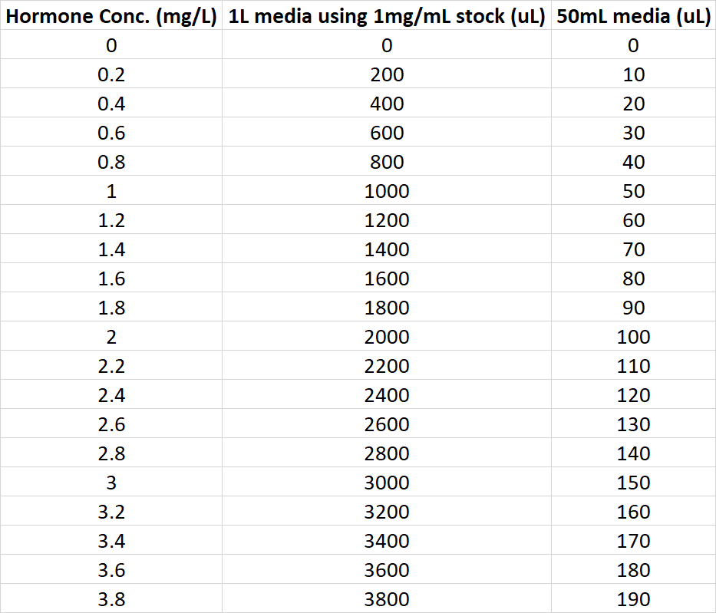

1. Once the hormone is added, cap the 50mL tube, invert 5 times to thoroughly mix, and dispense ~25mL per sterile petri dish. Each concentration gets 2 dishes. Use a new sterile tube for each concentration and don’t worry about being precise with pouring into the petri dishes once the hormones are added. Do, however pay very close attention when dispensing 50mL into the tube initially as this is critical for consistent concentrations. Try to repeat the exact level of media across all the tubes. A variance of 2mL +/- will give a 4% error in the expected concentration. This is about the maximum of error permissible for this experiment so please be extra cautions during this step.
2. Once all 40 dishes have been poured, allow them to solidify closed for 30 minutes. Ensure each dish has a label or marking denoting the concentration. A more thorough label will be written once the petunia leaf disks are plated. Once cooled, stack the dishes inverted to decrease condensation on the lid. Keep your work space tidy!
3. Unwrap, without touching the surface, the autoclaved self-healing cutting mat and place it in the center of your work space.
4. Using sterile technique, with a sterile tweezer and 6mm biopsy punch, carefully punch out 12 disks per leaf and begin plating them onto the hormone-laden petri dishes. Ideally plate one leaf’s wort of disks across the two dishes of the same concentration of hormone. If this is not possible, ensure that whatever disks you make are plated immediately onto media as drying will damage the tissue. You may have an excess or deficit of leaf material depending on how gently you handled the tissue during sterilization as well as other factors that may be beyond your control. If you are short on leaves, ensure that as many complete hormone levels are made (12 disks across two dishes) and note which levels were not tested. Distribute the usage of fresh sterile tweezers such that the chance of contaminant carry-over is minimized. Ideally, one tweezer per two dishes of media. Ensure the leaf disks are evenly spaced for optimal media diffusion.
5. Once all the petunia leaf disks are plated, stack them up in the corner of your sterile work area and cut enough parafilm M tape for all 40 dishes to have two strips. I normally use two squares worth of parafilm per dish and I cut that into two strips lengthwise.
6. Wipe down each strip with a paper towel sprayed with 70% isopropanol to remove any dust attached to the parafilm.
7. Carefully stretch two strips around each petri dish in an overlapping fashion. This takes practice and you may need to try it a few times on a non-sterile dish before attempting it. It’s not sticky, but it has a lot of give so it will stretch further than you think. Give about 1cm of feed per 4cm of stretch for optimal results. Again, this is hard to explain and better left to your own methods via practice.
8. Record a proper label onto each petri dish lid around the perimeter such that no light is blocked.
9. Place the petri dishes under 3000 lux lights with a 16hr/day photoperiod via outlet timer and observe for 2 weeks.
10. Record how many leaf disks produced callus at the end of two weeks and any abnormalities therein.
11. Graph the qualitative data and determine which hormone concentration gave the best results.

Normally, the tissue will be transferred to fresh media every two weeks but this experiment can be halted here or, if you so choose, continue the replating of the ones that showed promising callus generation using the hormone concentration that petri dish represents. Ideally ALL of the petri dishes will have at least one replate but this is not necessary as one can infer form the first two weeks the efficacy of the hormone concentrations in question.